Lab Report No 7



Digital Signal Processing

Submitted By:

Registration No:

Section:

“On my honor , as student of University of Engineering and Technology, I have neither given nor received unauthorized assistance on this academic work”

Student Signature:

Department of Computer Systems Engineering

University of Engineering and Technology Peshawar

**CSE 402L: Digital Signal Processing**

| **Demonstration of Concepts** | **Poor (Does not meet expectation (1))**  The student failed to demonstrate a clear understanding of the assignment concepts | **Fair (Meet Expectation (2-3))**  The student demonstrated a clear understanding of some of the assignment concepts | **Good (Exceeds Expectation (4-5)**  The student demonstrated a clear understanding of the assignment concepts | **Score**  **30%** |
| --- | --- | --- | --- | --- |
| **Accuracy** | The student completed ( <50%) tasks and provided MATLAB code and/or Simulink models with errors. Outputs shown are not correct in form of graphs (no labels) and/or tables along with incorrect analysis or remarks. | The student completed partial tasks (50% - <90%) with accurate MATLAB code and/or Simulink models. Correct outputs are shown in form of graphs (without labels) and/or tables along with correct analysis or remarks. | The student completed all required tasks (90%-100%) with accurate MATLAB code and/or Simulink models. Correct outputs are shown in form of labeled graphs and/or tables along with correct analysis or remarks. | **30%** |
| **Following Directions** | The student clearly failed to follow the verbal and written instructions to successfully complete the lab | The student failed to follow the some of the verbal and written instructions to successfully complete all requirements of the lab | The student followed the verbal and written instructions to successfully complete requirements of the lab | **20%** |
| **Time Utilization** | The student failed to complete even part of the lab in the allotted amount of time | The student failed to complete the entire lab in the allotted amount of time | The student completed the lab in its entirety in the allotted amount of time | **20%** |

Lab 9: Modeling Frequency Division Multiplexing/DE-multiplexing

**Title**: Implementing Frequency Division Multiplexing/De multiplexing using Matlab

**Objective:** Implement the following steps in Matlab to Multiplex three input voice signals at the transmitter end and Demultiplex and play them back at the Receiver end. Add random noise to the signal while propagating via the channel.

**Transmitter**

STEP 1, the signals are reproduced as they arrive

Process…………

Load three voice signals to Matlab and play them

STEP 2, plot the spectra of the signals as they arrive (Use fft and dsp.SpectrumAnalyzer  for comparison)

Process…………

The spectra of First Signal (Male)

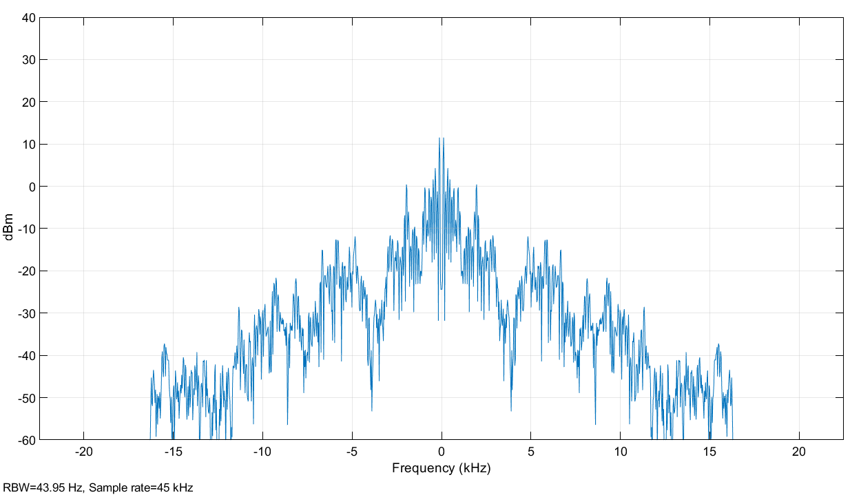

The spectra of Second Signal (Female)

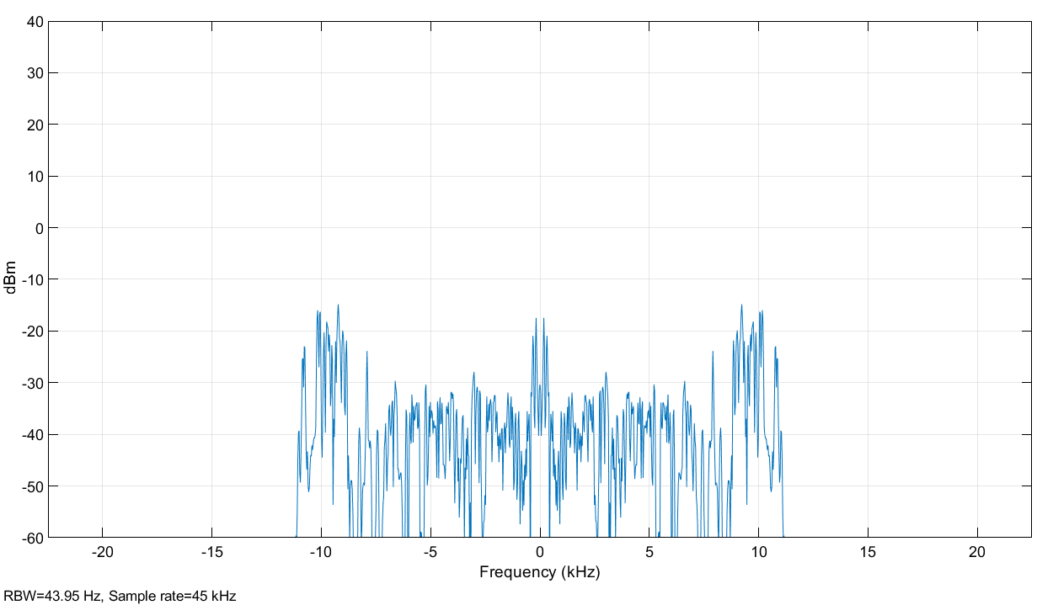

The spectra of Third Signal (Male)

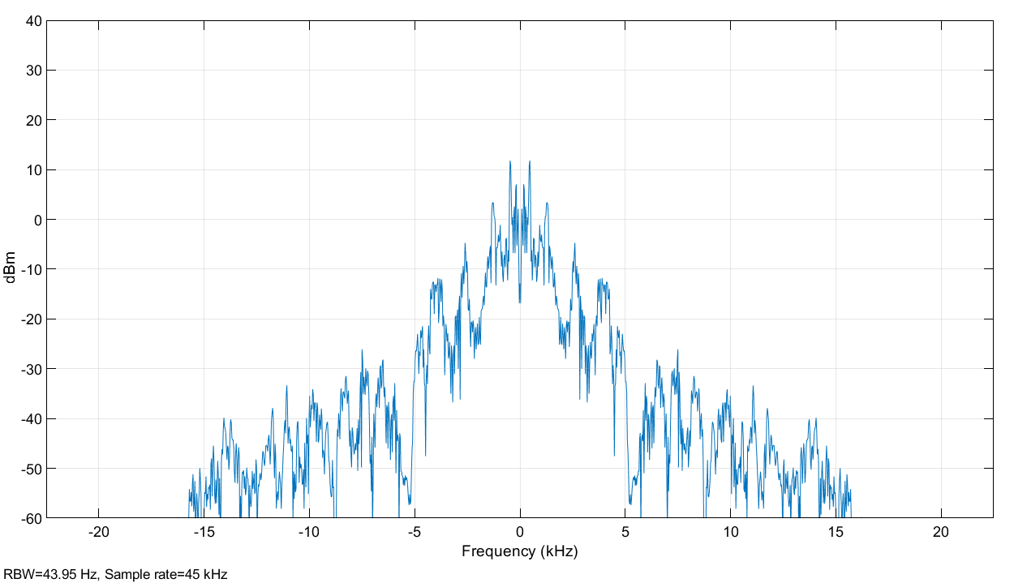

STEP 3, the signals are passed through a low pass filter and plotted

Process…………

The spectra of First Signal (Male) after passing through LPF

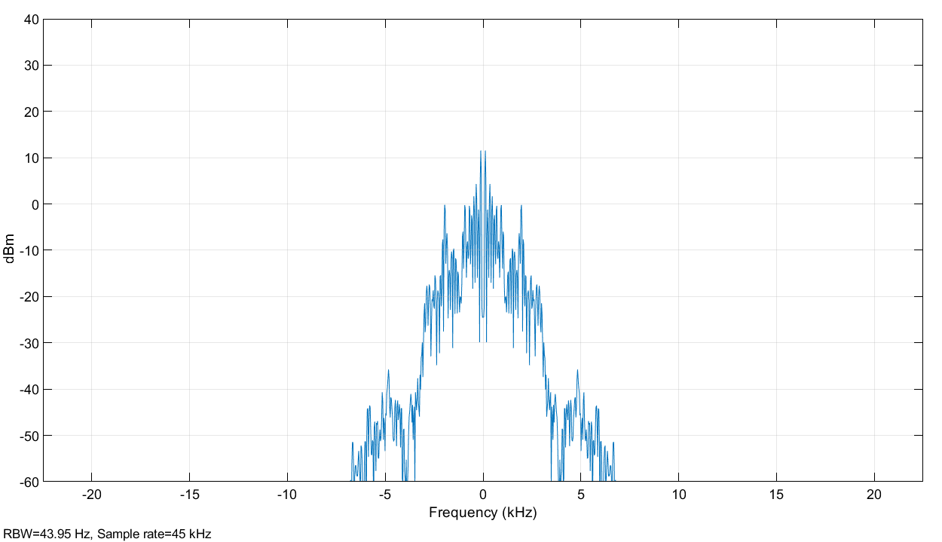

The spectra of Second Signal (Female) after passing through LPF

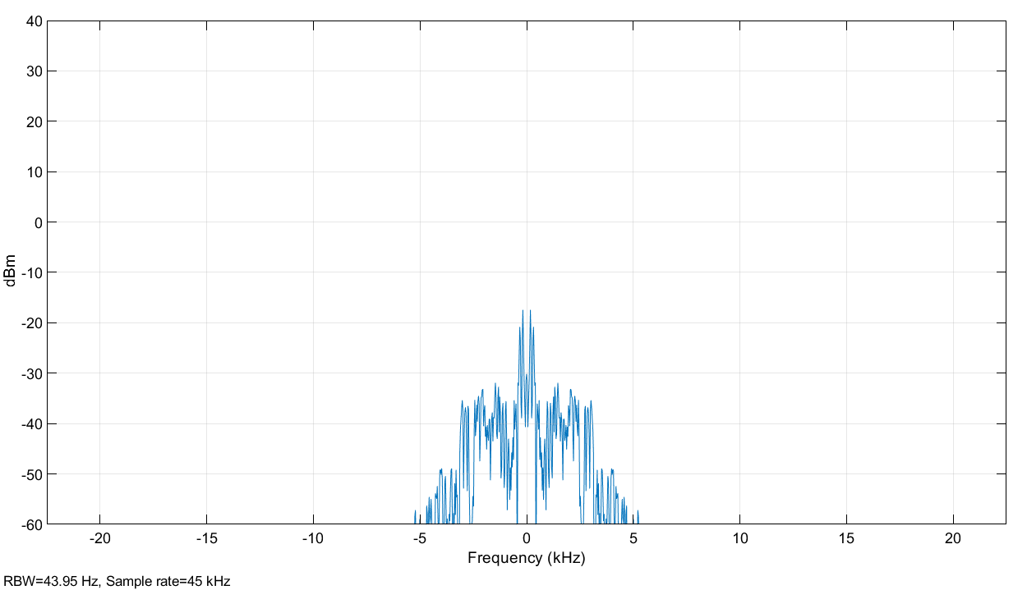

The spectra of Third Signal (Male) after passing through LPF

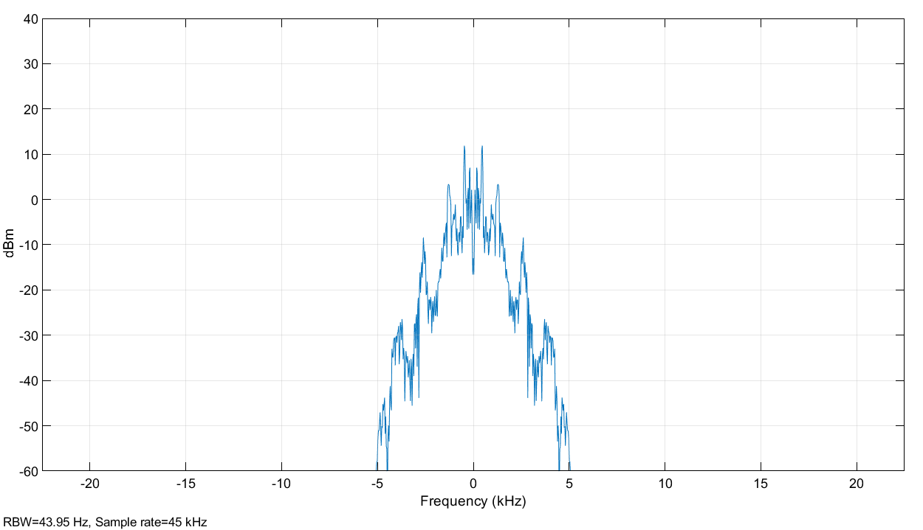

STEP 4, reproduce the signals after passing them through the filter

Process…………

Listen the signals again and observe the difference in quality. Why

STEP 5, the signals are modulated to different carriers

Process…………

First Signal after Modulation

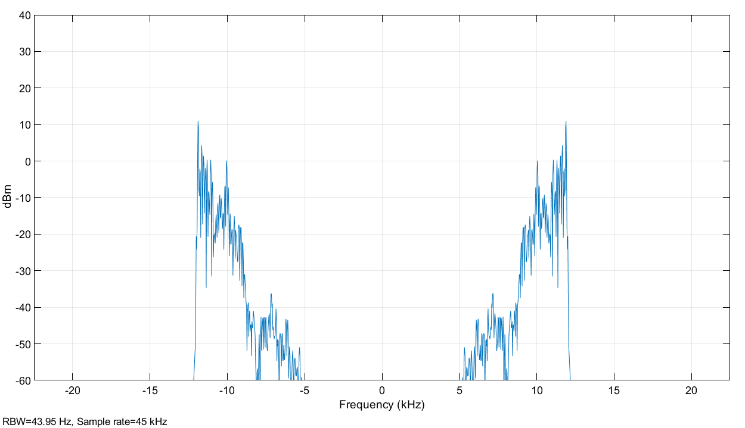

Second Signal after Modulation

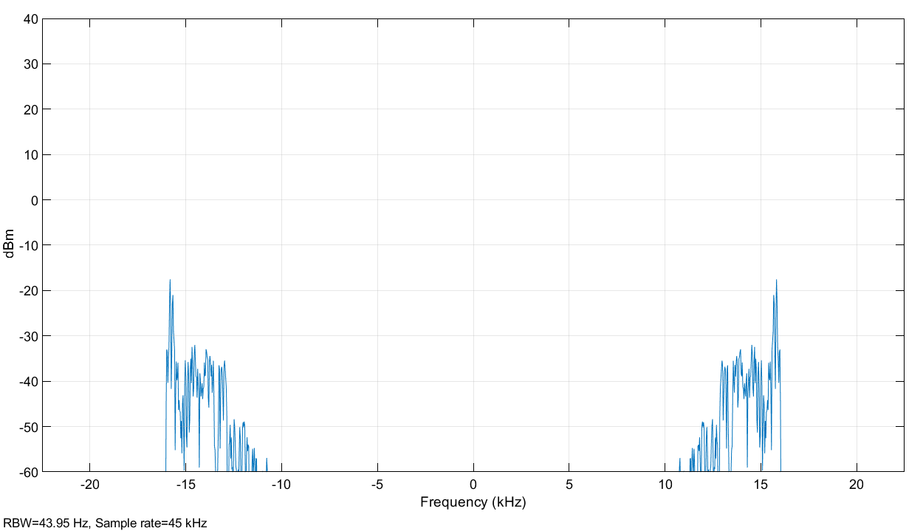

Third Signal after Modulation

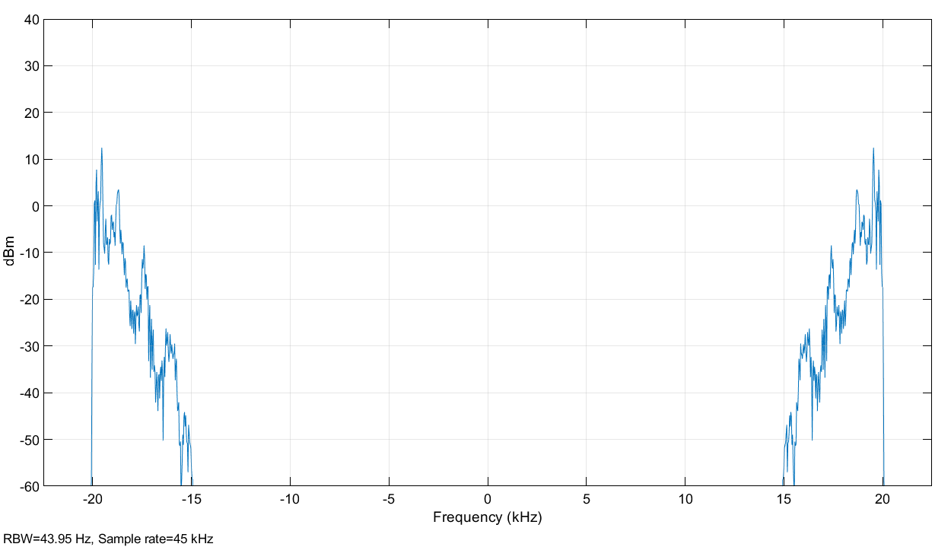

STEP 6, the modulated signals are filtered in the given band and added together

Process…………

Multiplexed Signal

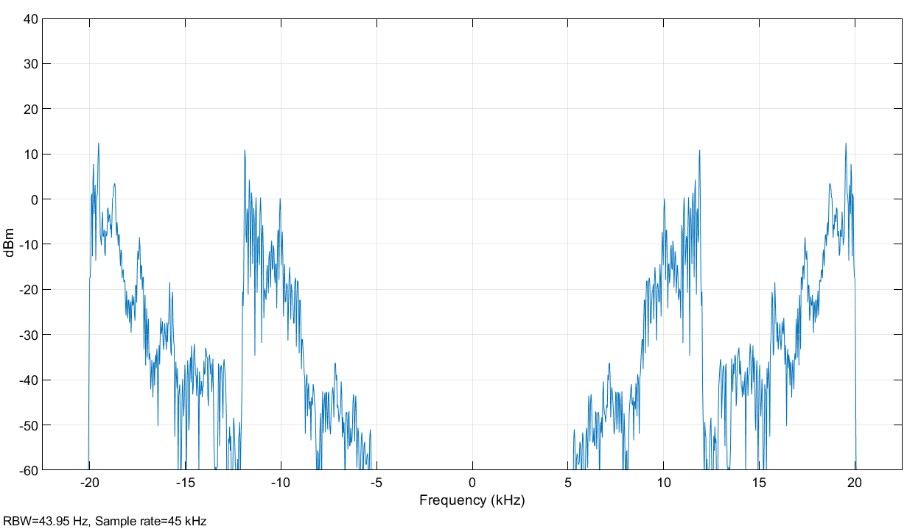

**Channel**

STEP 7, some noise is added to the transmitted signal

Process…………

Channel Effect, adding noise

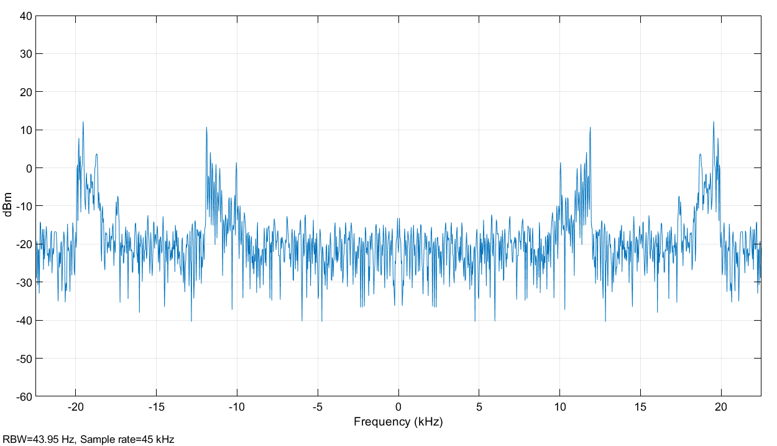

**Receiver**

STEP 8, upon arrival each band is filtered

Process…………

First Signal

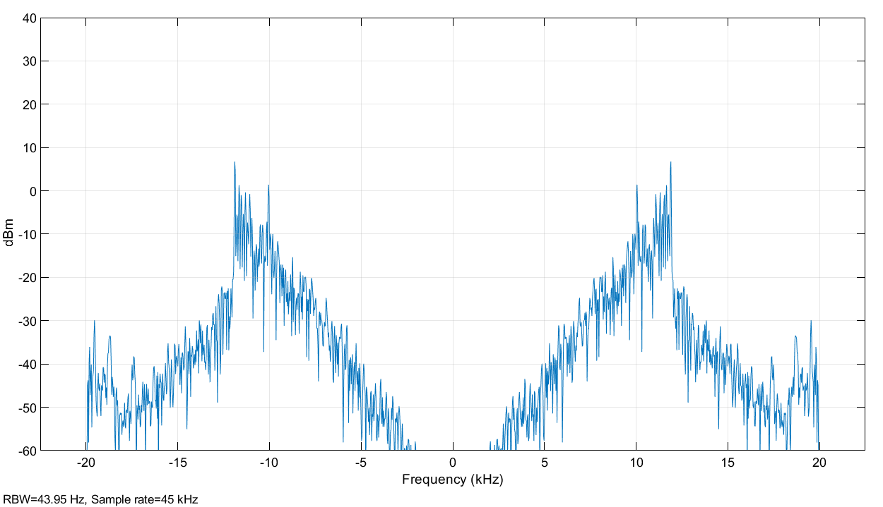

Second Signal

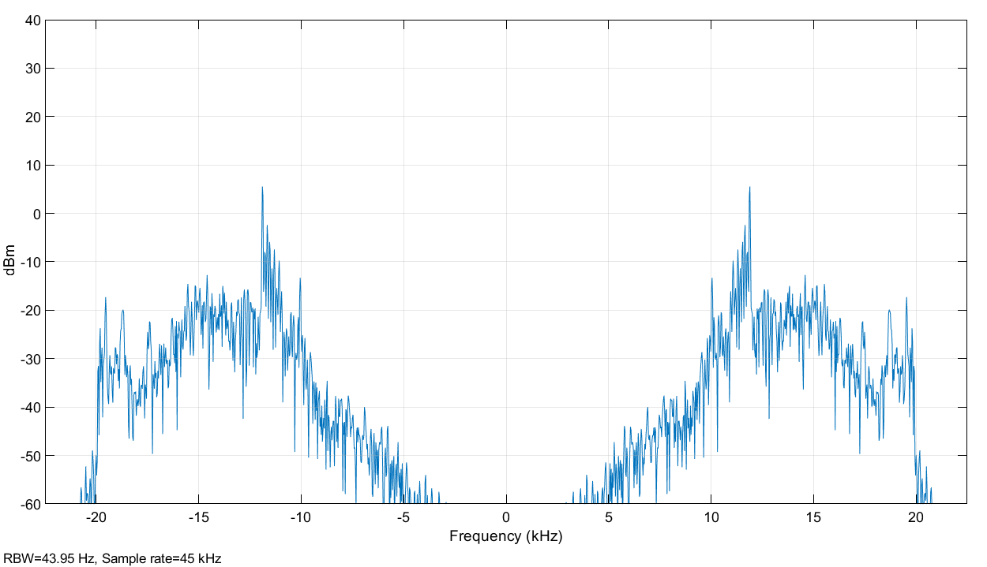

Third Signal

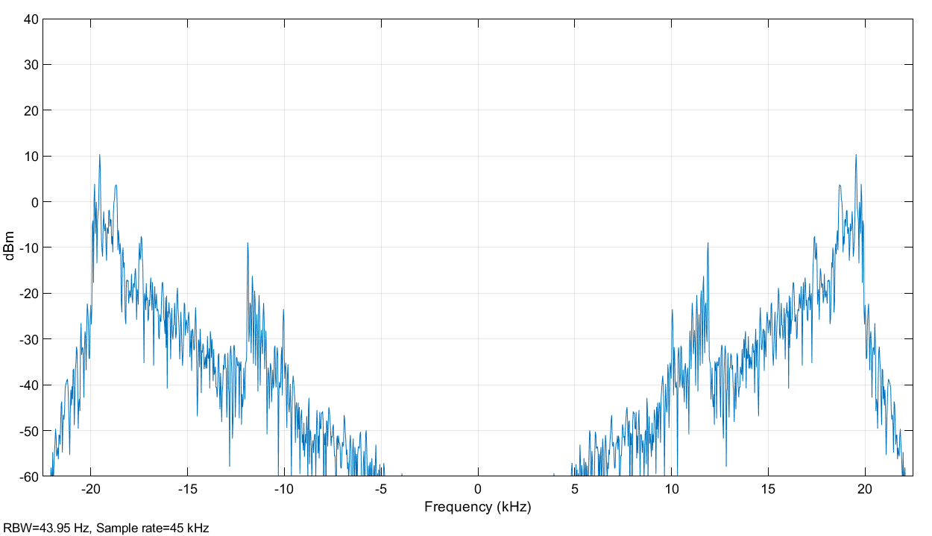

STEP 9, each recovered band is demodulated to return the signal at the indicated frequency

Process…………

Demodulating First Signal

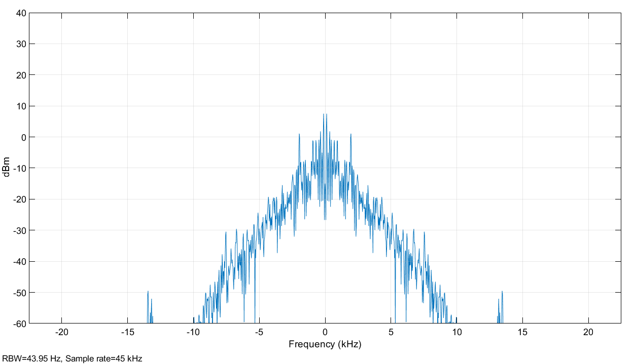

Demodulating Second Signal

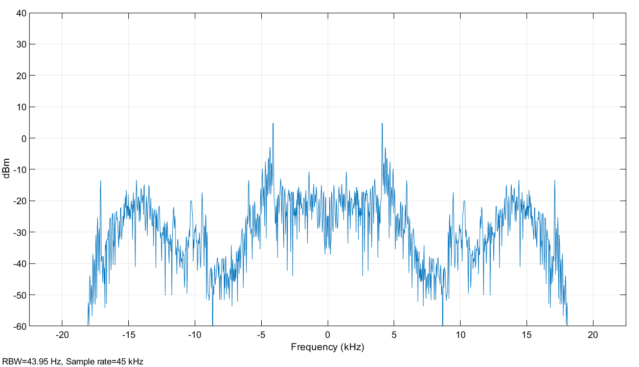

Demodulating Third Signal

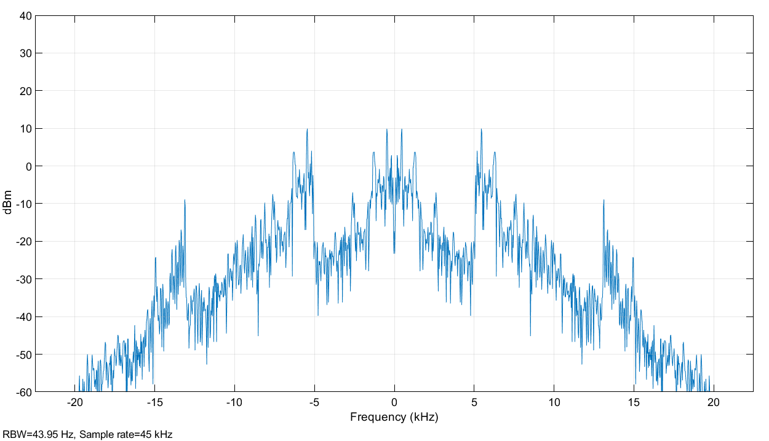

STEP 10, the recovered signal is passed through a low pass filter

Process…………

First Signal after passing through LPF

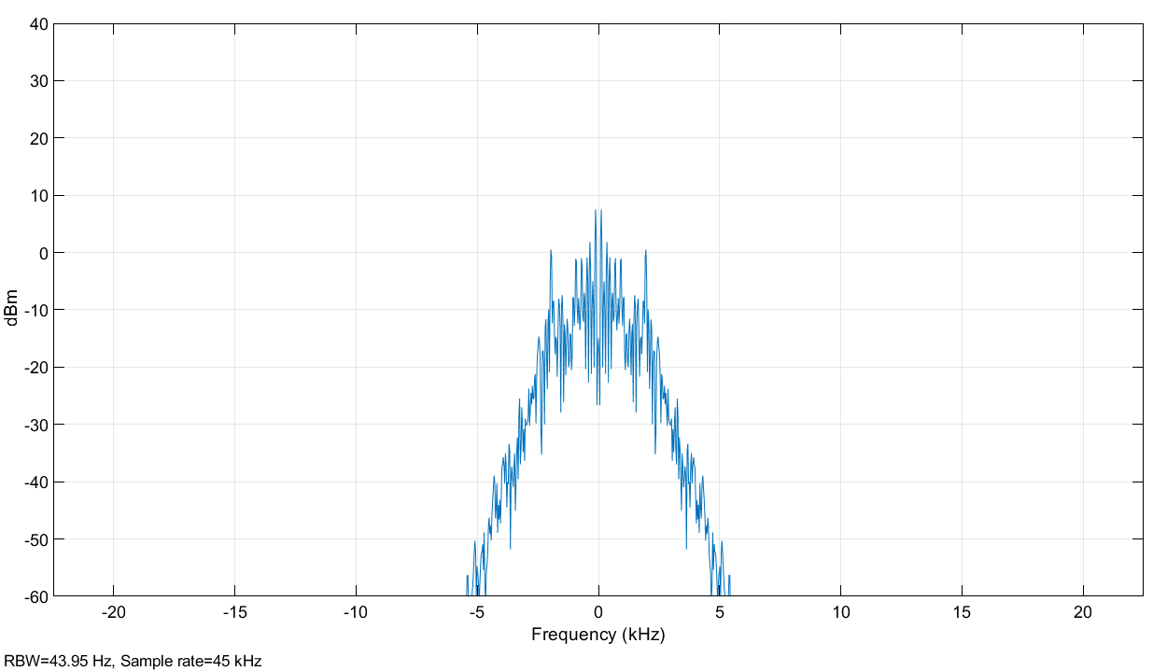

Second Signal after passing through LPF

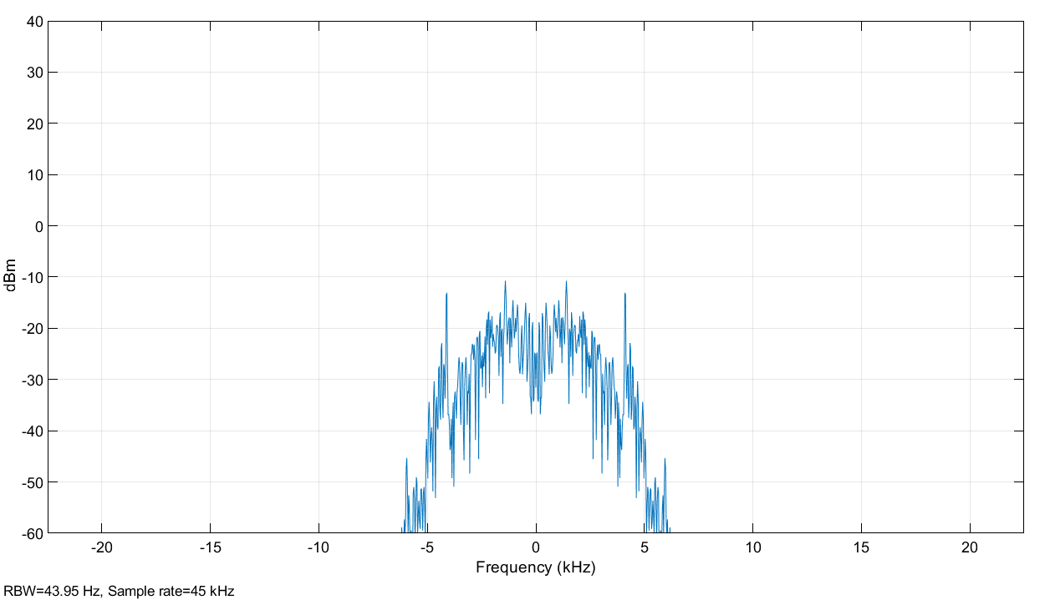

Third Signal after passing through LPF

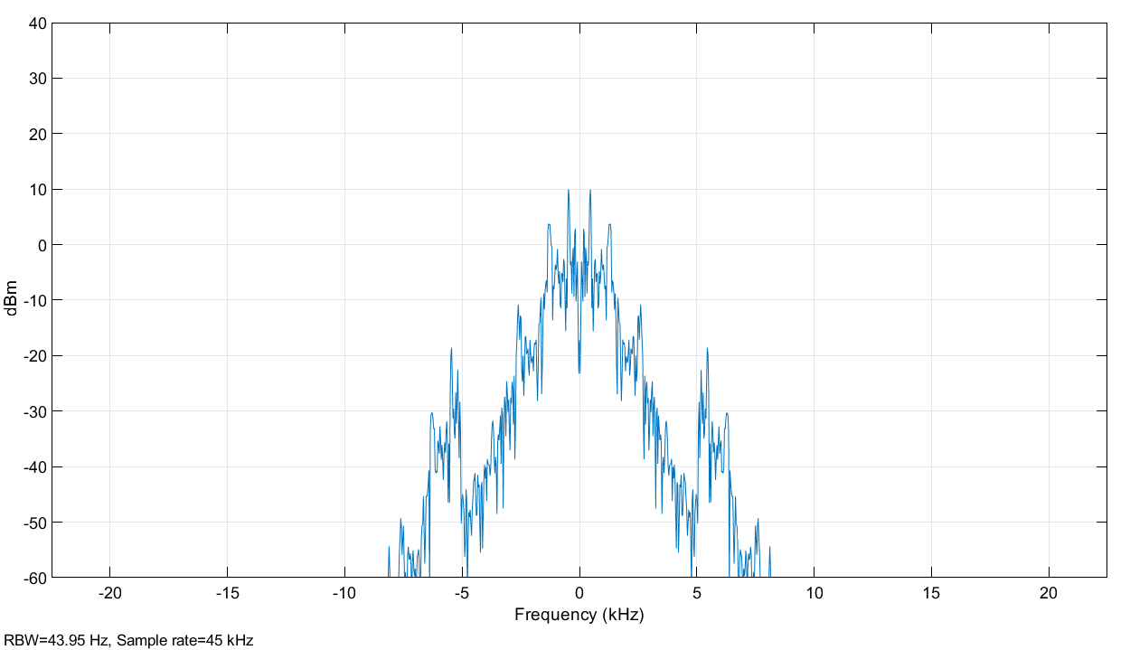

STEPS 11, Signal reproduced after transmission

Process…………

Listen the received signals and observe the quality

